String methods

1. charAt() : The charAt() method returns the character at a specified index (position) in a string. The index of the first character is 0, the second 1, so on. The index of the last character is string length – 1.

<!DOCTYPE html>
<html>
<body>
<h1>second character of "HELLO WORLD"</h1>
<p id="demo"></p>

<script>
let text = "HELLO WORLD";
let letter = text.charAt(1);

document.getElementById("demo").innerHTML = letter;
</script>

</body>
</html>

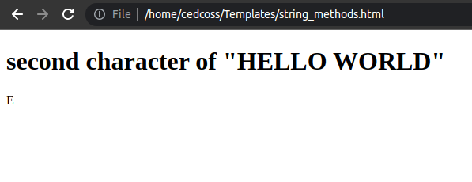

2. concat() : The concat() method joins two or more strings. The concat() method does not change the existing strings. The concat() method returns a new string.

<!DOCTYPE html>
<html>
<body>

<h1>below is the concated text</h1>
<p id="demo"></p>

<script>
let text1 = "Hello";
let text2 = "world!";
let text3 = "Have a nice day!";
let result = text1.concat(" ", text2, " ", text3);

document.getElementById("demo").innerHTML = result;
</script>

</body>

</html>

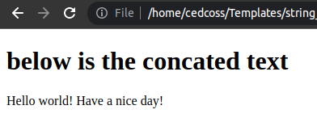

3. includes() : The includes() method returns true if a string contains a specified string. Otherwise it returns false.
The includes() method is case sensitive.

<!DOCTYPE html>
<html>
<body>

<p>Find "World":</p>

<p id="demo"></p>

<script>
let text = "Hello World, welcome to the universe.";
let result = text.includes("World");

document.getElementById("demo").innerHTML = result;
</script>

</body>
</html>

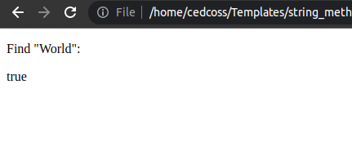

4. indexOf() : The indexOf() method returns the position of the first occurrence of a value in a string. The indexOf() method returns -1 if the value is not found. The indexOf() method is case sensitive.

<!DOCTYPE html>
<html>
<body>

<p>Find "welcome":</p>

<p id="demo"></p>

<script>
let text = "Hello world, welcome to the universe.";
let result = text.indexOf("welcome");

document.getElementById("demo").innerHTML = result + " is the index of 'welcome'";
</script>

</body>
</html>

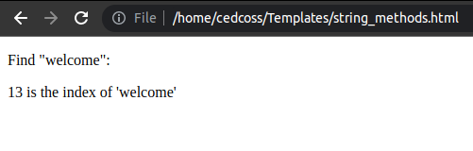
5. length : The length property returns the length of a string. The length property of an empty string is 0.

<!DOCTYPE html>
<html>
<body>

<p id="demo"></p>

<script>
let text = "Hello World!";
let length = text.length;

document.getElementById("demo").innerHTML = length;
</script>

</body>
</html>

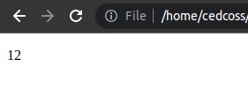

6. replace() : The replace() method searches a string for a value or a regular expression. The replace() method returns a new string with the value(s) replaced.
The replace() method does not change the original string.

<!DOCTYPE html>
<html>
<body>

<p id="demo">Mr Blue has a blue house.</p>

<script>
let str = document.getElementById("demo").innerHTML;
let res = str.replace("blue", "red");
document.getElementById("demo").innerHTML = res;
</script>

</body>
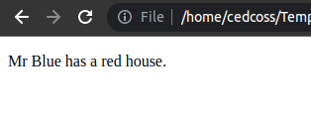
</html>

7. slice() : The slice() method extracts a part of a string. The slice() method returns the extracted part in a new string. The slice() method does not change the original string. The start and end parameters specifies the part of the string to extract.
A negative number selects from the end of the string.

<!DOCTYPE html>
<html>
<body>

<p>below is the the extracted part</p>

<p id="demo"></p>

<script>
let text = "Hello world!";
let result = text.slice(6);

document.getElementById("demo").innerHTML = result;
</script>

</body>
</html>

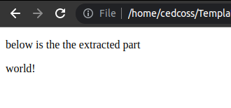

8. split() : The split() method splits a string into an array of substrings. The split() method returns the new array. The split() method does not change the original string. If (" ") is used as separator, the string is split between words.
<!DOCTYPE html>
<html>
<body>

<p id="demo"></p>

<script>
let text = "my name is aman.";
const myArray = text.split(" ");

document.getElementById("demo").innerHTML = myArray;
</script>

</body>
</html>
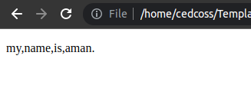

9. substr() : The substr() method extracts a part of a string. The substr() method begins at a specified position, and returns a specified number of characters. The substr() method does not change the original string. To extract characters from the end of the string, use a negative start position.

<!DOCTYPE html>
<html>
<body>
<p id="demo"></p>

<script>
let text = "Hello world!";
let result = text.substr(1);

document.getElementById("demo").innerHTML = result;
</script>

</body>
</html>
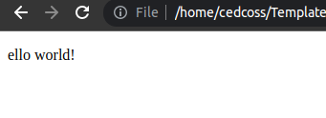

10. substring() : The substring() method extracts characters, between two indices (positions), from a string, and returns the substring. The substring() method extracts characters from start to end (excusive). The substring() method does not change the original string. If start is greater than end, arguments are swapped: (1, 4) = (4, 1). Start or end less than 0 are treated as 0.
<!DOCTYPE html>
<html>
<body>

<p id="demo"></p>

<script>
let text = "Hello world!";
let result = text.substring(0, 4);

document.getElementById("demo").innerHTML = result;
</script>

</body>
</html>

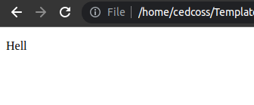

Array Methods
1. concat() : The concat() method concatenates (joins) two or more arrays.
The concat() method returns a new array, containing the joined arrays.
The concat() method does not change the existing arrays.

<!DOCTYPE html>
<html>
<body>

<p id="demo"></p>

<script>
const arr1 = ["aman", "Lion"];
const arr2 = ["Email", "Tabbu", "Linux"];

const children = arr1.concat(arr2);
document.getElementById("demo").innerHTML = children;
</script>

</body>
</html>
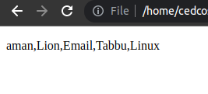

2. filter() :
The filter() method creates a new array filled with elements that pass a test provided by a function.
The filter() method does not execute the function for empty elements.
The filter() method does not change the original array.

<!DOCTYPE html>
<html>
<body>

<p id="demo"></p>

<script>
const ages = [32, 33, 16, 40];

document.getElementById("demo").innerHTML = ages.filter(checkAdult);

function checkAdult(age) {
return age >= 18;
}
</script>

</body>
</html>
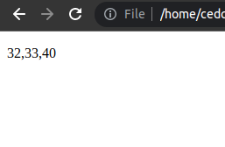

3. find() :
The find() method returns the value of the first element that passes a test.
The find() method executes a function for each array element.
The find() method retuns undefined if no elements are found.
The find() method does not execute the function for empty elements.
The find() method does not change the original array.

4. length : The length property sets or returns the number of elements in an array.

<!DOCTYPE html>
<html>
<body>

<p id="demo"></p>

<script>
const fruits = ["Banana", "Orange", "Apple", "Mango"];
let length = fruits.length;

document.getElementById("demo").innerHTML = length;
</script>

</body>
</html>
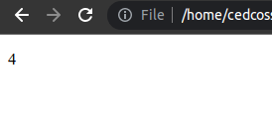

5. indexOf() :
The indexOf() method returns the first index (position) of a specified value.
The indexOf() method returns -1 if the value is not found.
The indexOf() method starts at a specified index and searches from left to right.
By default the search starts at the first element and ends at the last.
Negative start values counts from the last element (but still searches from right to left).

<!DOCTYPE html>
<html>
<body>

<p id="demo"></p>

<script>
const fruits = ["Banana", "Orange", "Apple", "Mango"];
let index = fruits.indexOf("Apple");

document.getElementById("demo").innerHTML = index;
</script>

</body>
</html>
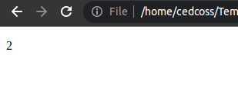

6. map() :
map() creates a new array from calling a function for every array element.
map() calls a function once for each element in an array.
map() does not execute the function for empty elements.
map() does not change the original array.

<!DOCTYPE html>
<html>
<body>

<p id="demo"></p>

<script>
const numbers = [4, 9, 16, 25];
document.getElementById("demo").innerHTML = numbers.map(Math.sqrt);
</script>

</body>
</html>

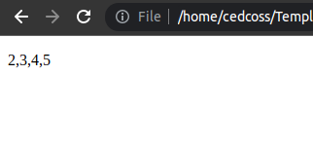

7. reduce() :
The reduce() method executes a reducer function for array element.
The reduce() method returns a single value: the function's accumulated result.
The reduce() method does not execute the function for empty array elements.
The reduce() method does not change the original array.

<!DOCTYPE html>
<html>

<body>

<p>Subtract the numbers in the array, starting from the left</p>

<p id="demo"></p>

<script>
const numbers = [175, 50, 25];
document.getElementById("demo").innerHTML = numbers.reduce(myFunc);

function myFunc(total, num) {
return total - num;
}
</script>

</body>

</html>

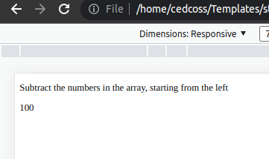

8. some() :
The some() method checks if any array elements pass a test (provided as a function).
The some() method executes the function once for each array element:
- If the function returns true, some() returns true and stops.
- If the function returns false, some() returns false and stops.
The some() method does not execute the function for empty array elements.
The some() method does not change the original array.

<!DOCTYPE html>
<html>
<body>

<p>The some() method checks if any of the elements in an array pass a test (provided as a function).</p>

<p id="demo"></p>

<script>
const ages = [3, 10, 18, 20];
document.getElementById("demo").innerHTML = ages.some(checkAdult);

function checkAdult(age) {
return age > 18;
}
</script>

</body>
</html>

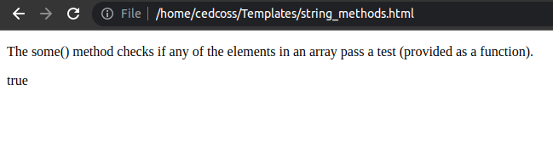
9. pop() :
The pop() method removes (pops) the last element of an array.
The pop() method changes the original array.
The pop() method returns the removed element.

<!DOCTYPE html>
<html>
<body>

<p>pop() removes the last element of an array.</p>

<p id="demo"></p>

<script>
const fruits = ["Banana", "Orange", "Apple", "Mango"];
fruits.pop();
document.getElementById("demo").innerHTML = fruits;
</script>

</body>
</html>

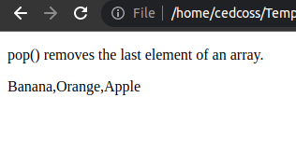

10. push() :
The push() method adds new items to the end of an array.
The push() method changes the length of the array.
The push() method returns the new length.

<!DOCTYPE html>
<html>
<body>

<p>push() adds new items to the end of an array:</p>

<p id="demo"></p>

<script>
const fruits = ["Banana", "Orange", "Apple", "Mango"];
fruits.push("Kiwi");

document.getElementById("demo").innerHTML = fruits;
</script>

</body>
</html>

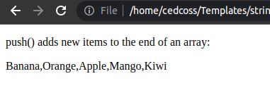

11. slice() :
The slice() method returns selected elements in an array, as a new array.
The slice() method selects from a given start, up to a (not inclusive) given end.
The slice() method does not change the original array.
<!DOCTYPE html>
<html>
<body>

<p>Array.slice() returns selected array elements as a new array:</p>

<p id="demo"></p>

<script>
const fruits = ["Banana", "Orange", "Lemon", "Apple", "Mango"];
const citrus = fruits.slice(1, 3);

document.getElementById("demo").innerHTML = citrus;
</script>

</body>
</html>
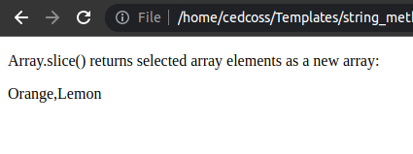

12. shift() :
The shift() method removes the first item of an array.
The shift() method changes the original array.
The shift() method returns the shifted element.

<!DOCTYPE html>
<html>
<body>

<p>shift() removes the first item of an array:</p>

<p id="demo"></p>

<script>
const fruits = ["Banana", "Orange", "Apple", "Mango"];
fruits.shift();

document.getElementById("demo").innerHTML = fruits;
</script>

</body>
</html>
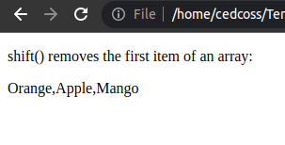

13. unshift() :
The unshift() method adds new elements to the beginning of an array.
The unshift() method overwrites the original array.

<!DOCTYPE html>
<html>
<body>

<p>unshift() adds new items to the beginning of an array</p>

<p id="demo"></p>

<script>
const fruits = ["Banana", "Orange", "Apple", "Mango"];
fruits.unshift("Lemon", "Pineapple");

document.getElementById("demo").innerHTML = fruits;
</script>

</body>
</html>

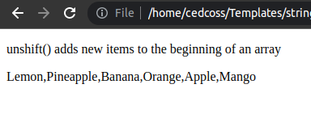

14. splice() :
The splice() method adds and/or removes array elements.
The splice() method overwrites the original array.

<!DOCTYPE html>
<html>
<body>

<p>The Array.splice() method adds and removes array elements</p>

<p id="demo"></p>

<script>
const fruits = ["Banana", "Orange", "Apple", "Mango", "Kiwi"];

// At position 2, remove 2 items:
fruits.splice(2, 2, "aam");

document.getElementById("demo").innerHTML = fruits;
</script>

</body>
</html>

